Recurrence Relation

Whenever we use Recursive in your code then only we use this Recurrence relation .

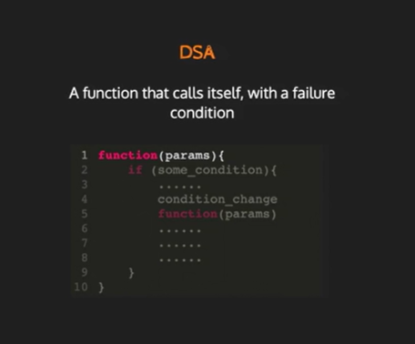

It is infinite loop until the condition is not meet

Example :

Factorial Using Recursive :

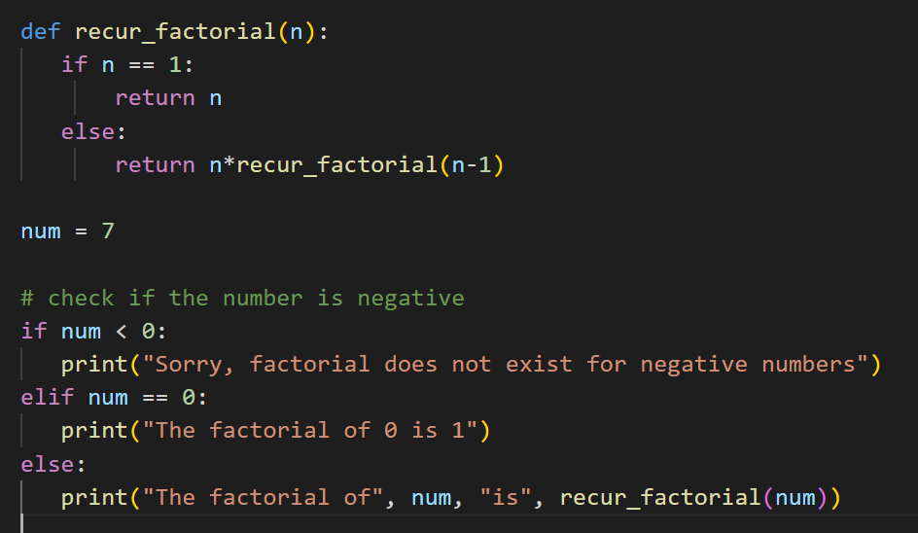

How it Works :

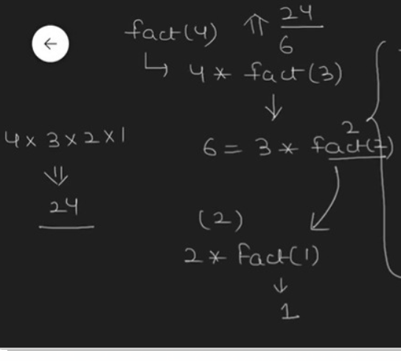

In Recursion Only Recurssion Relation works

In the above code What is the Recurssion Relation :

It is T(n) = T(n-1) 🡪 This T(n-1) + 1

Add 1 (+1) becozz of constant

is our recursive term

Here t is the function name .

SO here

T(n) = 1 if n ==0 or n==1 it is constant .

T(n) = T(n-1) + 1 when the n is greater than 1 .

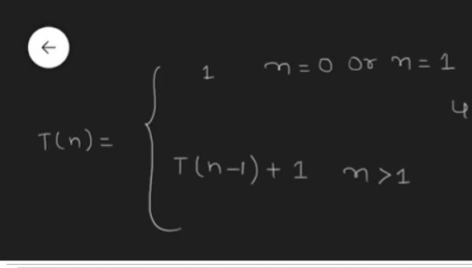

Term Recurssive

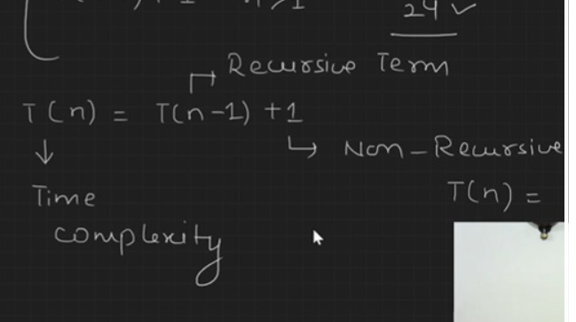

We can Find the Recurrence Relation in 3 types :

1. Substitution Method
2. Tree method
3. Master Therom